JavaScript Form

In this tutorial, we will learn, discuss, and understand the JavaScript form. We will also see the implementation of the JavaScript form for different purposes.

Here, we will learn the method to access the form, getting elements as the JavaScript form's value, and submitting the form.

Introduction to Forms

Forms are the basics of [HTML](https://www.javatpoint.com/html-tutorial)

. We use [HTML form element](https://www.javatpoint.com/html-form) in order to create the [JavaScript](https://www.javatpoint.com/javascript-tutorial) form.

For creating a form, we can use the following sample code:

1. **<html>**
2. **<head>**
3. **<title>** Login Form**</title>**
4. **</head>**
5. **<body>**
6. **<h3>** LOGIN **</h3>**
7. **<**form **name**="Login_form" onsubmit="submit_form()"**>**
8. **<h4>** USERNAME**</h4>**
9. **<input** type="text" placeholder="Enter your email id"**/>**
10. **<h4>** PASSWORD**</h4>**
11. **<input** type="password" placeholder="Enter your password"**/></br></br>**
12. **<input** type="submit" value="Login"**/>**
13. **<input** type="button" value="SignUp" onClick="create()"**/>**
14. **</form>**
15. **</html>**

In the code:

10 Sec

* Form name tag is used to define the name of the form. The name of the form here is "Login_form". This name will be referenced in the JavaScript form.
* The action tag defines the action, and the browser will take to tackle the form when it is submitted. Here, we have taken no action.
* The method to take action can be either **post** or **get**, which is used when the form is to be submitted to the server. Both types of methods have their own properties and rules.
* The input type tag defines the type of inputs we want to create in our form. Here, we have used input type as 'text', which means we will input values as text in the textbox.
* Net, we have taken input type as 'password' and the input value will be password.
* Next, we have taken input type as 'button' where on clicking, we get the value of the form and get displayed.

**Other than action and methods, there are the following useful methods also which are provided by the HTML Form Element**

* **submit ():** The method is used to submit the form.
* **reset ():** The method is used to reset the form values.

Referencing forms

Now, we have created the form element using HTML, but we also need to make its connectivity to JavaScript. For this, we use **the getElementById ()** method that references the html form element to the JavaScript code.

The syntax of using the [**getElementById()** method](https://www.javatpoint.com/document-getElementById()-method)

is as follows:

1. let form = document.getElementById('subscribe');

Using the Id, we can make the reference.

Submitting the form

Next, we need to submit the form by submitting its value, for which we use the **onSubmit()** method. Generally, to submit, we use a submit button that submits the value entered in the form.

The syntax of the submit() method is as follows:

1. **<input** type="submit" value="Subscribe"**>**

When we submit the form, the action is taken just before the request is sent to the server. It allows us to add an event listener that enables us to place various validations on the form. Finally, the form gets ready with a combination of HTML and JavaScript code.

Let's collect and use all these to create a [**Login form**](https://www.javatpoint.com/html-login-form)

and **SignUp form** and use both.

Login Form

1. **<html>**
2. **<head>**
3. **<title>** Login Form**</title>**
4. **</head>**
5. **<body>**
6. **<h3>** LOGIN **</h3>**
7. **<**form **name**="Login_form" onsubmit="submit_form()"**>**
8. **<h4>** USERNAME**</h4>**
9. **<input** type="text" placeholder="Enter your email id"**/>**
10. **<h4>** PASSWORD**</h4>**
11. **<input** type="password" placeholder="Enter your password"**/></br></br>**
12. **<input** type="submit" value="Login"**/>**
13. **<input** type="button" value="SignUp" onClick="create()"**/>**
14. **</form>**
15. **<script** type="text/javascript"**>**
16. function submit_form(){
17. alert("Login successfully");
18. }
19. function create(){
20. window.location="signup.html";
21. }
22. **</script>**
23. **</body>**
24. **</html>**

The output of the above code on clicking on Login button is shown below:

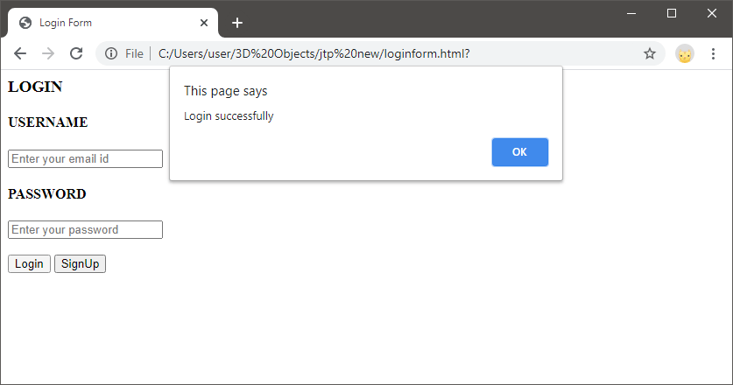

SignUp Form

1. **<html>**
2. **<head>**
3. **<title>** SignUp Page**</title>**
4. **</head>**
5. **<body** align="center" **>**
6. **<h1>** CREATE YOUR ACCOUNT**</h1>**
7. **<table** cellspacing="2" align="center" cellpadding="8" border="0"**>**
8. **<tr><td>** Name**</td>**
9. **<td><input** type="text" placeholder="Enter your name" id="n1"**></td></tr>**
10. **<tr><td>**Email **</td>**
11. **<td><input** type="text" placeholder="Enter your email id" id="e1"**></td></tr>**
12. **<tr><td>** Set Password**</td>**
13. **<td><input** type="password" placeholder="Set a password" id="p1"**></td></tr>**
14. **<tr><td>**Confirm Password**</td>**
15. **<td><input** type="password" placeholder="Confirm your password" id="p2"**></td></tr>**
16. **<tr><td>**
17. **<input** type="submit" value="Create" onClick="create_account()"**/>**
18. **</table>**
19. **<script** type="text/javascript"**>**
20. function create_account(){
21. var n=document.getElementById("n1").value;
22. var e=document.getElementById("e1").value;
23. var p=document.getElementById("p1").value;
24. var cp=document.getElementById("p2").value;
25. //Code for password validation
26. var letters = /^[A-Za-z]+$/;
27. var email_val = /^([a-zA-Z0-9_\.\-])+\@(([a-zA-Z0-9\-])+\.)+([a-zA-Z0-9]{2,4})+$/;
28. //other validations required code
29. if(n==''||e==''||p==''||cp==''){
30. alert("Enter each details correctly");
31. }
32. else if(!letters.test(n))
33. {
34. alert('Name is incorrect must contain alphabets only');
35. }
36. else if (!email_val.test(e))
37. {
38. alert('Invalid email format please enter valid email id');
39. }
40. else if(p!=cp)
41. {
42. alert("Passwords not matching");
43. }
44. else if(document.getElementById("p1").value.length **>** 12)
45. {
46. alert("Password maximum length is 12");
47. }
48. else if(document.getElementById("p1").value.length **<** **6**)
49. {
50. alert("Password minimum length is 6");
51. }
52. else{
53. alert("Your account has been created successfully... Redirecting to JavaTpoint.com");
54. window.location="https://www.Facebook.com/";
55. }
56. }
57. **</script>**
58. **</body>**
59. **</html>**

The output of the above code is shown below:

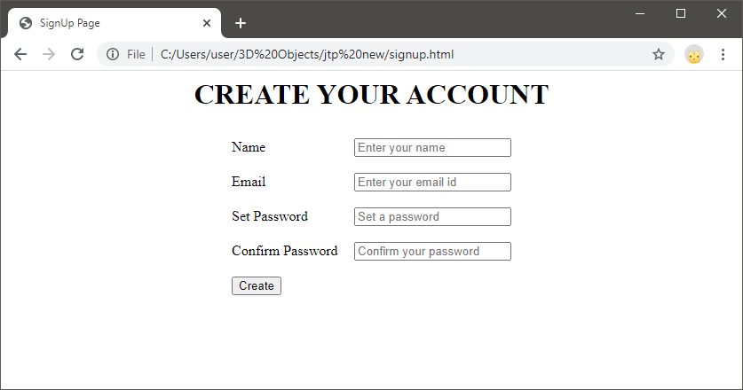

In this way, we can create forms in JavaScript with proper validations.